Coronavirus disease 2019 (COVID-19)
Situation Report – 100

Data as received by WHO from national authorities by 10:00 CEST, 29 April 2020

HIGHLIGHTS

- Globally, the number of total confirmed cases has exceeded 3 million.

- WHO has published a technical guidance titled ‘Strengthening Preparedness for COVID-19 in Cities and Urban Settings’. The guidance supports local leaders and policy-makers in cities and other urban settings in implementing actions that enhance the prevention, preparedness and readiness for COVID-19. The document can be found here.

- The WHO Regional Office for Europe has highlighted the critical importance of patient rehabilitation in light of the COVID-19 pandemic. More information is available here.

- WHO Regional Director for the Eastern Mediterranean Region, Dr. Ahmed Al- Mandhari, has called for ‘all to put aside their differences, find common ground, and work together for the sake of humanity’. More information is available here.
- The WHO Information Network for Epidemics (EPI-WIN) has rapidly built an innovative analysis capability to identify misleading sources, posts and narratives, and predict rising areas of concern and information voids. For more on this, see the ‘Subject in Focus’ below.

SITUATION IN NUMBERS
total (new cases in last 24 hours)

Globally
3 018 681 confirmed (66 005)
207 973 deaths (5376)

European Region
1 406 899 confirmed (21 750)
129 311 deaths (2882)

Region of the Americas
1 213 088 confirmed (33 481)
62 404 deaths (2193)

Eastern Mediterranean Region
176 928 confirmed (5690)
7304 deaths (156)

Western Pacific Region
146 449 confirmed (1064)
6037 deaths (39)

South-East Asia Region
51 351 confirmed (3003)
2001 deaths (84)

African Region
23 254 confirmed (1017)
903 deaths (22)

WHO RISK ASSESSMENT
Global Level Very High

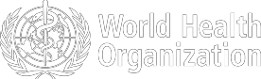

Figure 1. Countries, territories or areas with reported confirmed cases of COVID-19, 29 April 2020
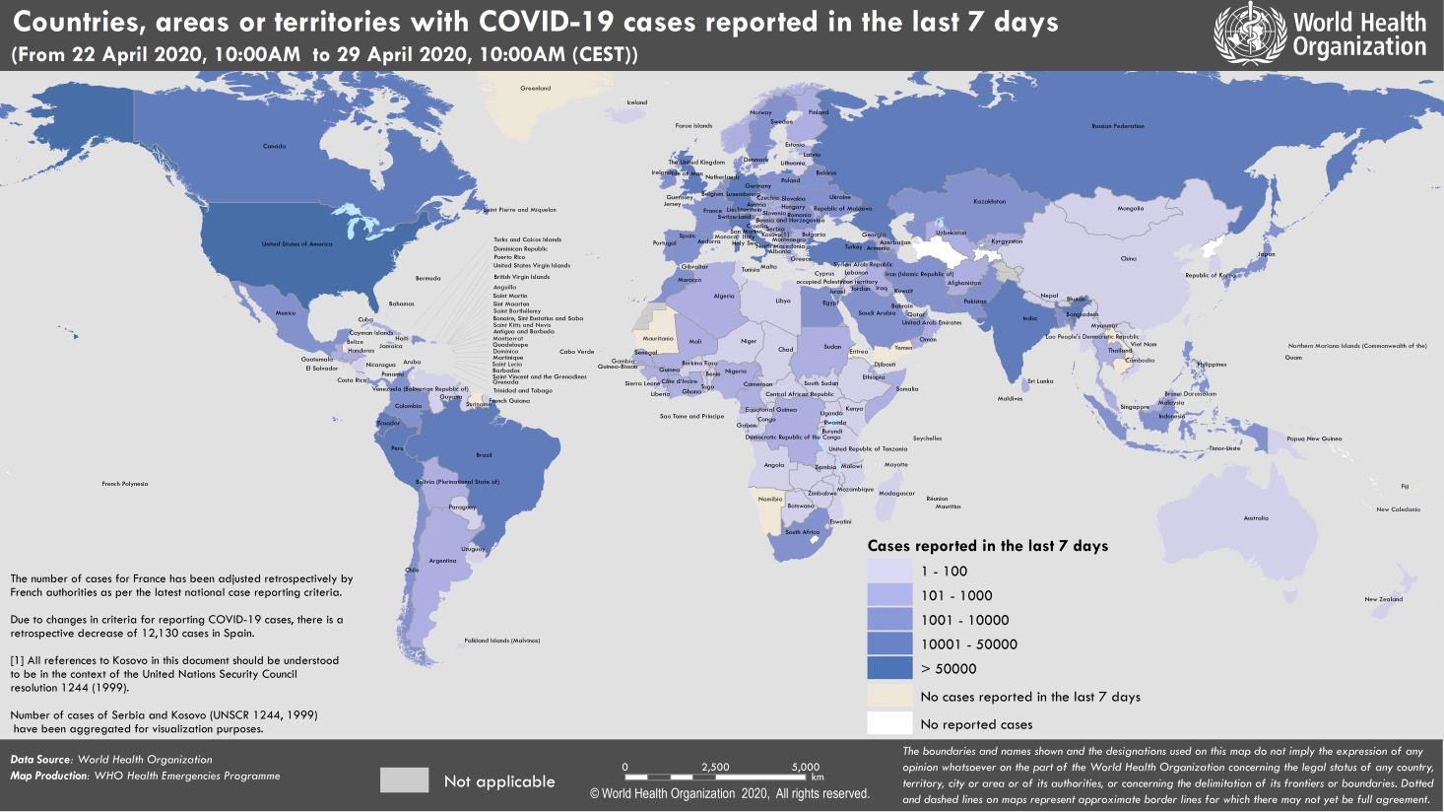

SUBJECT IN FOCUS: Adapting social media listening to fight the COVID-19 infodemic

Never before has so much real-time information been collated and shared in the public domain during a public health crisis. This is largely due to the rapid growth of digital communications and social networking which have brought about both positive and negative impacts on society. Today, we are fighting a massive ‘infodemic’– an overabundance of false or misleading information on COVID-19, which poses a grave threat to response efforts and public health. At the same time however, new and impactful measures to manage the infodemic have been identified.
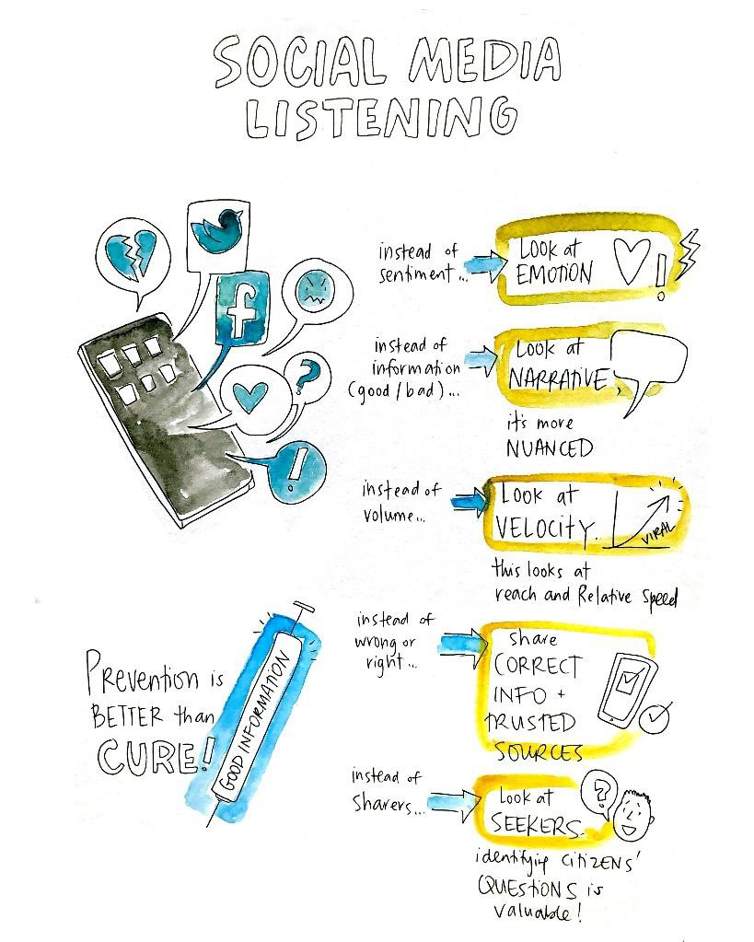

The WHO Information Network for Epidemics (EPI-WIN), in collaboration with research partners, has rapidly built an innovative analysis capability, to run a weekly study using digital media data to identify, understand and categorize the key concerns expressed by millions of people online.
The purpose of this groundbreaking work is to provide WHO with curated intelligence to fill information voids with solid facts from trusted sources before misleading information becomes viral, causing further damage to communities.

The public perception of misleading or false information often coincides with harmful rumour-spreading posts, groups and profiles that are widely spread on social media platforms. EPI-WIN’s work in this area therefore focuses
not only on identifying misleading sources, posts and narratives,
Figure 2: Shifting paradigm in social media listening

Source: Tim Zechin, Media Measurement; drawing by Sam Bradd

but on identifying or predicting rising areas of concern and information voids.

This is made possible by aggregating publicly available social and news media, web analytics as well as online search data, currently in the English language. Data sets are based around a newly developed pandemic public health taxonomy that focuses on four thematic areas: the cause, the illness, the interventions, and the treatment. In addition, a fifth area looks at the type of information shared and meta-conversations on mis- and dis-information.

These data, captured at a global level, provide the baseline for the analysis, and are examined by digital consultants to identify the most prevalent thematic areas, and themes that are seeing the highest level of growth. Analysts then detect the pace at which comments on these themes are shared, their networks and potentially threatening sources. This systematic approach gives the EPI-WIN team an early warning of the points of concern expressed by the digital public.

Advanced language analytics are also applied to the data, to measure the presence of emotional language and provide insight into how people are discussing topics. These also highlight whether there is a tangible week-on-week shift in emotional language used for each tracked taxonomy. The analysis focuses on emotions (including denial, sadness, anxiety, fear, anger and acceptance), rather than sentiment (positive versus negative). This enables WHO to share the types and formats of information needed to address the needs of the public in the most effective way.

Weekly insights highlight key topics of concern, including areas demonstrating an increase in the spread of misleading information, how and where that information has been spread, the context behind the spread, and the underlying narratives that need to be addressed through reliable information.

Applying this methodology to public health has provided invaluable insight, inspiring new ways of thinking and communicating risk during health emergencies. This research framework is now being used in Canada in French by

the Québec National Institute of Public Health (INSPQ) to guide public health communication strategies in the province. There is now an opportunity to compare the similarities and differences of how this insight can be used at the local level, and with the added layer of bilingual search options.

The general approach to analysis was presented at the recent WHO consultation on infodemic management framework.

Figure 3: EPI-WIN infodemic intelligence and signals monitoring

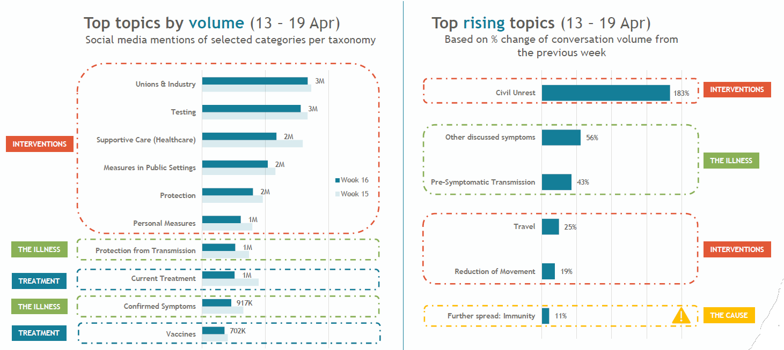
Source: Paolo Vacca and Amy Wright, Media Measurement

WHO Information network for Epidemics: www.who.int/epi-win
SURVEILLANCE
Reporting Country/ Territory/Area† | Total  ‡  cases |  | New confirmed cases | Total deaths | New deaths | Transmission classification§ | Days since last reported case
Western Pacific Region
China |  | 84369 | 22 | 4643 | 0 | Clusters of cases | 0
Singapore |  | 14951 | 528 | 14 | 0 | Clusters of cases | 0
Japan |  | 13852 | 276 | 389 | 13 | Clusters of cases | 0
Republic of Korea |  | 10761 | 9 | 246 | 2 | Clusters of cases | 0
Philippines |  | 7958 | 181 | 530 | 19 | Clusters of cases | 0
Australia |  | 6738 | 13 | 88 | 4 | Clusters of cases | 0
Malaysia |  | 5851 | 31 | 100 | 1 | Clusters of cases | 0
New Zealand |  | 1126 | 2 | 19 | 0 | Clusters of cases | 0
Viet Nam |  | 270 | 0 | 0 | 0 | Clusters of cases | 4
Brunei Darussalam |  | 138 | 0 | 1 | 0 | Sporadic cases | 9
Cambodia |  | 122 | 0 | 0 | 0 | Sporadic cases | 17
Mongolia |  | 38 | 0 | 0 | 0 | Sporadic cases | 2
Lao People's Democratic Republic |  | 19 | 0 | 0 | 0 | Sporadic cases | 16
Fiji |  | 18 | 0 | 0 | 0 | Sporadic cases | 8
Papua New Guinea |  | 8 | 0 | 0 | 0 | Sporadic cases | 6
Territories**
Guam |  | 140 | 2 | 5 | 0 | Clusters of cases | 0
French Polynesia |  | 58 | 0 | 0 | 0 | Sporadic cases | 1
New Caledonia |  | 18 | 0 | 0 | 0 | Sporadic cases | 26
Northern Mariana Islands (Commonwealth of the) |  | 14 | 0 | 2 | 0 | Pending | 11
European Region
Spain |  | 210773 | 1308 | 23822 | 632 | Pending | 0
Italy |  | 201505 | 2091 | 27359 | 382 | Community transmission | 0
The United Kingdom |  | 161149 | 3996 | 21678 | 586 | Community transmission | 0
Germany |  | 157641 | 1304 | 6115 | 202 | Community transmission | 0
France |  | 125464 | 0 | 23627 | 366 | Community transmission | 0
Turkey |  | 114653 | 2392 | 2992 | 92 | Community transmission | 0
Russian Federation |  | 99399 | 5841 | 972 | 105 | Clusters of cases | 0
Belgium |  | 47334 | 647 | 7331 | 124 | Community transmission | 0
Netherlands |  | 38416 | 171 | 4566 | 48 | Community transmission | 0

Table 1. Countries, territories or areas with reported laboratory-confirmed COVID-19 cases and deaths, by WHO region.* Data as of 29 April 2020

confirmed

Switzerland | 29181 | 100 | 1379 | 27 | Community transmission | 0
Portugal | 24322 | 295 | 948 | 20 | Community transmission | 0
Ireland | 19877 | 229 | 1159 | 57 | Community transmission | 0
Sweden | 19621 | 695 | 2355 | 81 | Community transmission | 0
Israel | 15782 | 316 | 212 | 10 | Pending | 0
Austria | 15314 | 58 | 569 | 20 | Community transmission | 0
Poland | 12218 | 316 | 596 | 34 | Community transmission | 0
Belarus | 12208 | 0 | 79 | 0 | Clusters of cases | 1
Romania | 11616 | 277 | 650 | 19 | Community transmission | 0
Ukraine | 9866 | 456 | 250 | 11 | Community transmission | 0
Denmark | 8851 | 153 | 434 | 7 | Pending | 0
Serbia | 8497 | 222 | 168 | 6 | Pending | 0
Norway | 7605 | 72 | 195 | 2 | Pending | 0
Czechia | 7504 | 55 | 227 | 4 | Community transmission | 0
Finland | 4740 | 45 | 199 | 6 | Pending | 0
Luxembourg | 3741 | 12 | 89 | 1 | Pending | 0
Republic of Moldova | 3638 | 157 | 109 | 6 | Pending | 0
Kazakhstan | 3078 | 96 | 25 | 0 | Pending | 0
Hungary | 2727 | 78 | 300 | 9 | Clusters of cases | 0
Greece | 2534 | 0 | 136 | 0 | Community transmission | 1
Croatia | 2047 | 8 | 63 | 4 | Community transmission | 0
Uzbekistan | 1955 | 31 | 8 | 0 | Clusters of cases | 0
Armenia | 1932 | 65 | 30 | 0 | Clusters of cases | 0
Iceland | 1795 | 3 | 10 | 0 | Community transmission | 0
Azerbaijan | 1717 | 39 | 22 | 0 | Clusters of cases | 0
Estonia | 1660 | 13 | 50 | 0 | Pending | 0
Bosnia and Herzegovina | 1588 | 24 | 62 | 2 | Community transmission | 0
Lithuania | 1449 | 0 | 44 | 3 | Community transmission | 2
North Macedonia | 1421 | 22 | 71 | 6 | Clusters of cases | 0
Slovenia | 1408 | 1 | 86 | 3 | Community transmission | 0
Bulgaria | 1399 | 36 | 58 | 0 | Pending | 0
Slovakia | 1384 | 3 | 20 | 2 | Clusters of cases | 0
Cyprus | 837 | 15 | 20 | 0 | Clusters of cases | 0
Latvia | 836 | 18 | 13 | 0 | Community transmission | 0
Albania | 766 | 30 | 30 | 2 | Clusters of cases | 0
Andorra | 753 | 5 | 41 | 1 | Community transmission | 0

Kyrgyzstan | 729 | 21 | 8 | 0 | Pending | 0
San Marino | 553 | 15 | 41 | 0 | Community transmission | 0
Georgia | 517 | 6 | 6 | 0 | Community transmission | 0
Malta | 450 | 0 | 4 | 0 | Pending | 1
Montenegro | 321 | 0 | 7 | 0 | Clusters of cases | 2
Liechtenstein | 83 | 0 | 1 | 0 | Pending | 3
Monaco | 68 | 0 | 1 | 0 | Sporadic cases | 15
Holy See | 10 | 1 | 0 | 0 | Sporadic cases | 0
Territories**
Kosovo[1] | 790 | 10 | 22 | 0 | Community transmission | 0
Isle of Man | 308 | 0 | 20 | 2 | Pending | 4
Jersey | 283 | 2 | 19 | 0 | Pending | 0
Guernsey | 247 | 0 | 13 | 0 | Community transmission | 1
Faroe Islands | 187 | 0 | 0 | 0 | Pending | 5
Gibraltar | 141 | 0 | 0 | 0 | Clusters of cases | 2
Greenland | 11 | 0 | 0 | 0 | Pending | 23
South-East Asia Region
India | 31332 | 1897 | 1007 | 73 | Clusters of cases | 0
Indonesia | 9511 | 415 | 773 | 8 | Community transmission | 0
Bangladesh | 6462 | 549 | 155 | 3 | Pending | 0
Thailand | 2947 | 9 | 54 | 0 | Pending | 0
Sri Lanka | 619 | 96 | 7 | 0 | Clusters of cases | 0
Maldives | 245 | 31 | 0 | 0 | Clusters of cases | 0
Myanmar | 150 | 4 | 5 | 0 | Clusters of cases | 0
Nepal | 54 | 2 | 0 | 0 | Sporadic cases | 0
Timor-Leste | 24 | 0 | 0 | 0 | Clusters of cases | 5
Bhutan | 7 | 0 | 0 | 0 | Sporadic cases | 6
Eastern Mediterranean Region
Iran (Islamic Republic of) | 92584 | 1112 | 5877 | 71 | Community transmission | 0
Saudi Arabia | 20077 | 1266 | 152 | 8 | Clusters of cases | 0
Pakistan | 14885 | 970 | 327 | 35 | Clusters of cases | 0
Qatar | 11921 | 677 | 10 | 0 | Pending | 0
United Arab Emirates | 11380 | 541 | 89 | 7 | Pending | 0
Egypt | 5042 | 260 | 359 | 22 | Clusters of cases | 0
Morocco | 4252 | 132 | 165 | 3 | Clusters of cases | 0
Kuwait | 3440 | 152 | 23 | 1 | Clusters of cases | 0
Bahrain | 2811 | 88 | 8 | 0 | Clusters of cases | 0
Oman | 2274 | 143 | 10 | 0 | Clusters of cases | 0
Iraq | 1928 | 81 | 90 | 2 | Clusters of cases | 0
Afghanistan | 1827 | 124 | 60 | 0 | Clusters of cases | 0
Djibouti | 1072 | 37 | 2 | 0 | Clusters of cases | 0
Tunisia | 975 | 8 | 40 | 1 | Community transmission | 0
Lebanon | 717 | 7 | 24 | 0 | Clusters of cases | 0

Somalia | 528 | 48 | 28 | 2 | Sporadic cases | 0
Jordan | 449 | 0 | 8 | 1 | Clusters of cases | 1
Sudan | 318 | 43 | 25 | 3 | Sporadic cases | 0
Libya | 61 | 0 | 2 | 0 | Clusters of cases | 4
Syrian Arab Republic | 43 | 0 | 3 | 0 | Community transmission | 1
Yemen | 1 | 0 | 0 | 0 | Pending | 18
Territories**
occupied Palestinian territory | 343 | 1 | 2 | 0 | Clusters of cases | 0
Region of the Americas
United States of America | 983457 | 22541 | 50492 | 1322 | Community transmission | 0
Brazil | 66501 | 4613 | 4543 | 338 | Community transmission | 0
Canada | 49014 | 1698 | 2766 | 149 | Community transmission | 0
Peru | 28699 | 1182 | 782 | 54 | Community transmission | 0
Ecuador | 24258 | 1018 | 871 | 208 | Community transmission | 0
Mexico | 15529 | 852 | 1434 | 83 | Community transmission | 0
Chile | 14365 | 552 | 207 | 9 | Community transmission | 0
Dominican Republic | 6416 | 123 | 286 | 4 | Community transmission | 0
Panama | 6021 | 242 | 167 | 2 | Community transmission | 0
Colombia | 5597 | 218 | 253 | 9 | Community transmission | 0
Argentina | 4019 | 127 | 197 | 5 | Community transmission | 0
Cuba | 1437 | 48 | 58 | 2 | Clusters of cases | 0
Bolivia (Plurinational State of) | 1014 | 64 | 53 | 3 | Clusters of cases | 0
Honduras | 702 | 41 | 64 | 3 | Clusters of cases | 0
Costa Rica | 697 | 2 | 6 | 0 | Clusters of cases | 0
Uruguay | 620 | 14 | 15 | 0 | Clusters of cases | 0
Guatemala | 530 | 30 | 15 | 0 | Clusters of cases | 0
Jamaica | 364 | 59 | 7 | 0 | Clusters of cases | 0
El Salvador | 345 | 22 | 8 | 0 | Clusters of cases | 0
Venezuela (Bolivarian Republic of) | 329 | 4 | 10 | 0 | Clusters of cases | 0
Paraguay | 230 | 2 | 9 | 0 | Community transmission | 0
Trinidad and Tobago | 116 | 0 | 8 | 0 | Sporadic cases | 1
Bahamas | 80 | 0 | 11 | 0 | Clusters of cases | 1
Barbados | 80 | 1 | 6 | 0 | Clusters of cases | 0
Haiti | 76 | 2 | 6 | 0 | Clusters of cases | 0
Guyana | 74 | 0 | 8 | 0 | Clusters of cases | 2
Antigua and Barbuda | 24 | 0 | 3 | 0 | Clusters of cases | 6
Belize | 18 | 0 | 2 | 0 | Sporadic cases | 14

Grenada | 18 | 0 | 0 | 0 | Clusters of cases | 2
Dominica | 16 | 0 | 0 | 0 | Clusters of cases | 18
Saint Kitts and Nevis | 15 | 0 | 0 | 0 | Sporadic cases | 8
Saint Lucia | 15 | 0 | 0 | 0 | Sporadic cases | 17
Saint Vincent and the Grenadines | 15 | 0 | 0 | 0 | Sporadic cases | 1
Nicaragua | 13 | 0 | 3 | 0 | Pending | 2
Suriname | 10 | 0 | 1 | 0 | Sporadic cases | 25
Territories**
Puerto Rico | 1400 | 11 | 54 | 1 | Clusters of cases | 0
Martinique | 175 | 0 | 14 | 0 | Clusters of cases | 2
Guadeloupe | 149 | 0 | 11 | 1 | Clusters of cases | 4
French Guiana | 124 | 13 | 1 | 0 | Clusters of cases | 0
Bermuda | 110 | 1 | 6 | 0 | Clusters of cases | 0
Aruba | 100 | 0 | 2 | 0 | Clusters of cases | 6
Sint Maarten | 75 | 1 | 13 | 0 | Clusters of cases | 0
Cayman Islands | 70 | 0 | 1 | 0 | Clusters of cases | 3
United States Virgin Islands | 59 | 0 | 4 | 0 | Clusters of cases | 1
Saint Martin | 38 | 0 | 3 | 0 | Sporadic cases | 6
Curaçao | 16 | 0 | 1 | 0 | Sporadic cases | 1
Falkland Islands (Malvinas) | 13 | 0 | 0 | 0 | Clusters of cases | 3
Turks and Caicos Islands | 12 | 0 | 1 | 0 | Sporadic cases | 1
Montserrat | 11 | 0 | 1 | 0 | Sporadic cases | 15
Bonaire, Sint Eustatius and Saba | 6 | 0 | 0 | 0 | Sporadic cases | 1
British Virgin Islands | 6 | 0 | 1 | 0 | Sporadic cases | 3
Saint Barthélemy | 6 | 0 | 0 | 0 | Sporadic cases | 29
Anguilla | 3 | 0 | 0 | 0 | Sporadic cases | 25
Saint Pierre and Miquelon | 1 | 0 | 0 | 0 | Sporadic cases | 21
African Region
South Africa | 4996 | 203 | 93 | 3 | Community transmission | 0
Algeria | 3649 | 132 | 437 | 5 | Community transmission | 0
Cameroon | 1705 | 84 | 58 | 2 | Clusters of cases | 0
Ghana | 1671 | 121 | 16 | 5 | Clusters of cases | 0
Nigeria | 1337 | 0 | 40 | 0 | Community transmission | 1
Guinea | 1240 | 77 | 7 | 0 | Community transmission | 0
Côte d’Ivoire | 1183 | 19 | 14 | 0 | Clusters of cases | 0
Senegal | 823 | 88 | 9 | 0 | Clusters of cases | 0
Niger | 709 | 8 | 31 | 2 | Clusters of cases | 0
Burkina Faso | 638 | 6 | 42 | 0 | Community transmission | 0
Democratic Republic of the Congo | 491 | 20 | 30 | 0 | Clusters of cases | 0
Mali | 424 | 16 | 24 | 1 | Clusters of cases | 0

Kenya | 374 | 11 | 14 | 0 | Clusters of cases | 0
Mauritius | 332 | 0 | 10 | 1 | Community transmission | 2
Equatorial Guinea | 315 | 57 | 1 | 0 | Clusters of cases | 0
United Republic of Tanzania | 300 | 0 | 10 | 0 | Clusters of cases | 4
Gabon | 238 | 62 | 3 | 0 | Clusters of cases | 0
Rwanda | 212 | 5 | 0 | 0 | Clusters of cases | 0
Congo | 207 | 0 | 8 | 0 | Clusters of cases | 1
Liberia | 141 | 8 | 16 | 0 | Clusters of cases | 0
Madagascar | 128 | 0 | 0 | 0 | Clusters of cases | 2
Ethiopia | 126 | 2 | 3 | 0 | Clusters of cases | 0
Cabo Verde | 113 | 7 | 1 | 0 | Sporadic cases | 0
Sierra Leone | 104 | 5 | 5 | 1 | Clusters of cases | 0
Togo | 99 | 0 | 6 | 0 | Clusters of cases | 1
Zambia | 95 | 6 | 3 | 0 | Sporadic cases | 0
Uganda | 79 | 0 | 0 | 0 | Sporadic cases | 1
Mozambique | 76 | 0 | 0 | 0 | Sporadic cases | 2
Guinea-Bissau | 73 | 0 | 1 | 0 | Sporadic cases | 1
Eswatini | 71 | 6 | 1 | 0 | Sporadic cases | 0
Benin | 64 | 0 | 1 | 0 | Sporadic cases | 2
Chad | 52 | 6 | 2 | 2 | Sporadic cases | 0
Central African Republic | 50 | 8 | 0 | 0 | Sporadic cases | 0
Eritrea | 39 | 0 | 0 | 0 | Sporadic cases | 10
Malawi | 36 | 0 | 3 | 0 | Sporadic cases | 1
South Sudan | 34 | 28 | 0 | 0 | Sporadic cases | 0
Zimbabwe | 32 | 1 | 4 | 0 | Sporadic cases | 0
Angola | 27 | 0 | 2 | 0 | Sporadic cases | 1
Botswana | 23 | 1 | 1 | 0 | Sporadic cases | 0
Namibia | 16 | 0 | 0 | 0 | Sporadic cases | 23
Burundi | 15 | 0 | 1 | 0 | Sporadic cases | 2
São Tomé and Príncipe | 11 | 3 | 0 | 0 | Sporadic cases | 0
Seychelles | 11 | 0 | 0 | 0 | Sporadic cases | 22
Gambia | 10 | 0 | 1 | 0 | Sporadic cases | 8
Mauritania | 7 | 0 | 1 | 0 | Sporadic cases | 18
Territories**
Mayotte | 460 | 27 | 4 | 0 | Clusters of cases | 0
Réunion | 418 | 0 | 0 | 0 | Clusters of cases | 1
Subtotal for all Regions | 3017969 | 66005 | 207960 | 5376
International conveyance (Diamond Princess) | 712 | 0 | 13 | 0 | Not Applicable†† | 44
Grand total | 3018681 | 66005 | 207973 | 5376
*Countries are arranged by official WHO regions, in descending order by the number of total confirmed cases. Overseas territories** are listed under the WHO region that administers them.
†The designations employed and the presentation of the material in this publication do not imply the expression of any opinion whatsoever on the part of WHO concerning the legal status of any country, territory, city or area or of its authorities, or concerning the delimitation of its frontiers or boundaries. Dotted and dashed lines on maps represent approximate border lines for which there may not yet be full agreement.
‡Case classifications are based on WHO case definitions for COVID-19.
§Transmission classification is based on a process of country/territory/area self-reporting. Classifications are reviewed on a weekly basis and may be upgraded or downgraded as new information becomes available. Not all locations within a given country/territory/area are equally affected; countries/territories/areas experiencing multiple types of transmission are classified in the highest category reported. Within a given transmission category, different countries/territories/areas may have differing degrees of transmission as indicated by the differing numbers of cases, recency of cases, and other factors.
Terms:
- No cases: Countries/territories/areas with no confirmed cases (not shown in table)
- Sporadic cases: Countries/territories/areas with one or more cases, imported or locally detected
- Clusters of cases: Countries/territories/areas experiencing cases, clustered in time, geographic location and/or by common exposures
- Community transmission: Countries/area/territories experiencing larger outbreaks of local transmission defined through an assessment of factors including, but not limited to:
  - Large numbers of cases not linkable to transmission chains
  - Large numbers of cases from sentinel lab surveillance
  - Multiple unrelated clusters in several areas of the country/territory/area

** “Territories” include territories, areas, overseas dependencies and other jurisdictions of similar status
[1] All references to Kosovo should be understood to be in the context of the United Nations Security Council resolution 1244 (1999).
†† As the international conveyance (Diamond Princess) is no longer occupied, transmission classification cannot be applied.

Due to differences in reporting methods, retrospective data consolidation, and reporting delays, the number of new cases may not always reflect the exact difference between yesterday’s and today’s totals. WHO COVID-19 Situation Reports present official counts of confirmed COVID-19 cases, thus differences between WHO reports and other sources of COVID-19 data using different inclusion criteria and different data cutoff times are to be expected.

The number of cases for France has been adjusted retrospectively by French authorities as per the latest national case reporting criteria. Erratum: Total cases and new cases have been revised for Singapore.

Figure 4. Epidemic curve of confirmed COVID-19, by date of report and WHO region through 29 April 2020

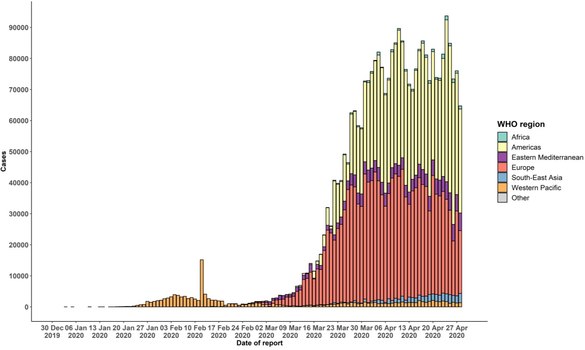
STRATEGIC OBJECTIVES

WHO’s strategic objectives for this response are to:

- Interrupt human-to-human transmission including reducing secondary infections among close contacts and health care workers, preventing transmission amplification events, and preventing further international spread*;
- Identify, isolate and care for patients early, including providing optimized care for infected patients;
- Identify and reduce transmission from the animal source;
- Address crucial unknowns regarding clinical severity, extent of transmission and infection, treatment options, and accelerate the development of diagnostics, therapeutics and vaccines;
- Communicate critical risk and event information to all communities and counter misinformation;
- Minimize social and economic impact through multisectoral partnerships.

*This can be achieved through a combination of public health measures, such as rapid identification, diagnosis and management of the cases, identification and follow up of the contacts, infection prevention and control in health care settings, implementation of health measures for travelers, awareness-raising in the population and risk communication.

PREPAREDNESS AND RESPONSE
- To view all technical guidance documents regarding COVID-19, please go to this webpage.
- WHO has developed interim guidance for laboratory diagnosis, advice on the use of masks during home care and in health care settings in the context of COVID-19 outbreak, clinical management, infection prevention and control in health care settings, home care for patients with suspected novel coronavirus, risk communication and community engagement and Global Surveillance for human infection with COVID-19.
- WHO is working closely with International Air Transport Association (IATA) and have jointly developed a guidance document to provide advice to cabin crew and airport workers, based on country queries. The guidance can be found on the IATA webpage.
- WHO has been in regular and direct contact with Member States where cases have been reported. WHO is also informing other countries about the situation and providing support as requested.
- WHO is working with its networks of researchers and other experts to coordinate global work on surveillance, epidemiology, mathematical modelling, diagnostics and virology, clinical care and treatment, infection prevention and control, and risk communication. WHO has issued interim guidance for countries, which are updated regularly.
- WHO has prepared a disease commodity package that includes an essential list of biomedical equipment, medicines and supplies necessary to care for patients with COVID-19.
- WHO has provided recommendations to reduce risk of transmission from animals to humans.
- WHO has published an updated recommendations for international traffic in relation to COVID-19 outbreak .
- WHO has activated the R&D blueprint to accelerate diagnostics, vaccines, and therapeutics.
- OpenWHO is an interactive, web-based, knowledge-transfer platform offering free online courses to improve the response to health emergencies. COVID-19 resources are hosted on 2 learning channels: one for courses in official WHO languages here and a second for courses in additional national languages here.
  - There are more than 1.5 million enrolments in the platform's courses to support the COVID-19 response. Specifically, WHO has developed courses on the following topics:
  - A general introduction to emerging respiratory viruses, including novel coronaviruses (available
in Arabic, Chinese, English, French, Russian, Spanish, Bengali, Hindi, Hungarian, Indian Sign Language, Indonesian, Macedonian, Persian, Portuguese, Serbian, Turkish and Vietnamese);
  - Clinical care for Severe Acute Respiratory Infection (SARI) (available in English, French, Russian, Spanish, Indonesian, Portuguese and Vietnamese);
  - Health and safety briefing for respiratory diseases – ePROTECT (available in Arabic, Chinese, English, French, Russian, Spanish, Indonesian and Portuguese);
  - Infection Prevention and Control for COVID-19 (available
in Chinese, English, French, Russian, Spanish, Indonesian, Italian, Japanese, Macedonian, Portuguese, Ser bian and Turkish);
  - COVID-19 operational planning guidelines and partners platform to support country preparedness and response (available in Chinese, English, French, Russian, Indonesian and Portuguese);
  - SARI treatment facility design (available in Arabic, English, Italian and Portuguese);
  - An introduction to Go.Data – field data collection, chains of transmission and contact follow-up (available in English and coming soon in additional languages);
  - How to put on and remove personal protective equipment (PPE) for COVID-19 (available in English and coming soon in additional languages); and
  - Standard precautions for hand hygiene (available in English and coming soon in additional languages).
- WHO is providing guidance on early investigations, which are critical in an outbreak of a new virus. The data collected from the protocols can be used to refine recommendations for surveillance and case definitions, to characterize the key epidemiological transmission features of COVID-19, help understand spread, severity, spectrum of disease, impact on the community and to inform operational models for implementation of countermeasures such as case isolation, contact tracing and isolation. Several protocols are available here. One such protocol is for the investigation of early COVID-19 cases and contacts (the “First Few X (FFX) Cases and contact investigation protocol for 2019-novel coronavirus (2019-nCoV) infection”). The protocol is designed to gain an early understanding of the key clinical, epidemiological and virological characteristics of the first cases of COVID-19 infection detected in any individual country, to inform the development and updating of public health guidance to manage cases and reduce the potential spread and impact of infection.

RECOMMENDATIONS AND ADVICE FOR THE PUBLIC

If you are not in an area where COVID-19 is spreading or have not travelled from an area where COVID-19 is spreading or have not been in contact with an infected patient, your risk of infection is low. It is understandable that you may feel anxious about the outbreak. Get the facts from reliable sources to help you accurately determine your risks so that you can take reasonable precautions (see Frequently Asked Questions). Seek guidance from WHO, your healthcare provider, your national public health authority or your employer for accurate information on COVID-19 and whether COVID-19 is circulating where you live. It is important to be informed of the situation and take appropriate measures to protect yourself and your family (see Protection measures for everyone).

If you are in an area where there are cases of COVID-19 you need to take the risk of infection seriously. Follow the advice of WHO and guidance issued by national and local health authorities. For most people, COVID-19 infection will cause mild illness however, it can make some people very ill and, in some people, it can be fatal. Older people, and those with pre-existing medical conditions (such as cardiovascular disease, chronic respiratory disease or diabetes) are at risk for severe disease (See Protection measures for persons who are in or have recently visited (past 14 days) areas where COVID-19 is spreading).

CASE DEFINITIONS

WHO periodically updates the Global Surveillance for human infection with coronavirus disease (COVID-19) document which includes case definitions.

For easy reference, case definitions are included below.
Suspect case
- A patient with acute respiratory illness (fever and at least one sign/symptom of respiratory disease, e.g., cough, shortness of breath), AND a history of travel to or residence in a location reporting community transmission of COVID-19 disease during the 14 days prior to symptom onset.
OR
- A patient with any acute respiratory illness AND having been in contact with a confirmed or probable COVID-19 case (see definition of contact) in the last 14 days prior to symptom onset;
OR
- A patient with severe acute respiratory illness (fever and at least one sign/symptom of respiratory disease, e.g., cough, shortness of breath; AND requiring hospitalization) AND in the absence of an alternative diagnosis that fully explains the clinical presentation.

Probable case
- A suspect case for whom testing for the COVID-19 virus is inconclusive.
  - Inconclusive being the result of the test reported by the laboratory.
OR
- A suspect case for whom testing could not be performed for any reason.

Confirmed case
A person with laboratory confirmation of COVID-19 infection, irrespective of clinical signs and symptoms.
- Technical guidance for laboratory testing can be found here.

Definition of contact
A contact is a person who experienced any one of the following exposures during the 2 days before and the 14 days after the onset of symptoms of a probable or confirmed case:
- Face-to-face contact with a probable or confirmed case within 1 meter and for more than 15 minutes;
- Direct physical contact with a probable or confirmed case;
- Direct care for a patient with probable or confirmed COVID-19 disease without using proper personal protective equipment1; OR
- Other situations as indicated by local risk assessments.

Note: for confirmed asymptomatic cases, the period of contact is measured as the 2 days before through the 14 days after the date on which the sample was taken which led to confirmation.

Definition of COVID-19 death
COVID-19 death is defined for surveillance purposes as a death resulting from a clinically compatible illness in a probable or confirmed COVID-19 case, unless there is a clear alternative cause of death that cannot be related to COVID disease (e.g. trauma). There should be no period of complete recovery between the illness and death.

Further guidance for certification and classification (coding) of COVID-19 as cause of death is available here.

1 World Health Organization. Infection prevention and control during health care when COVID-19 is suspected https://www.who.int/publications-detail/infection-prevention-and-control-during-health-care-when-novel-coronavirus-(ncov)- infection-is-suspected-20200125

